🌈 Rainbow Children Community Preschool Newsletter
Dear Parents and Carers,
Welcome back to preschool! We hope you all enjoyed a lovely and restful half term break. It has been wonderful to see the children return, ready for another exciting term full of learning, laughter, and discovery.
Below is an overview of what we will be focusing on this term.

🎨 Colour Tables This Term
- Pink: 23.2.26 – 9.3.26
- Yellow: 9.3.26 – 23.3.26
- Green: 23.3.26 – 31.3.26
The children enjoy recognising these colours in their environment.

🔤 Jolly Phonics
This term we will be focusing on:
- ‘m’ – 23.2.26 – 9.3.26
- ‘d’ – 9.3.26 – 23.3.26
- ‘g’ – 23.3.26 – 31.3.26
We will practice recognising the letters, saying the correct sounds, and identifying words that begin with each sound.
You can help at home by:
- Practicing the sound (e.g., “mmmm” not “em”)
- Finding objects that start with each letter
- Encouraging mark-making and letter formation through drawing and writing

🔢 Numbers
Our number focus this term will be:
- Number 11 – 23.2.26 – 9.3.26
- Number 12 – 9.3.26 – 23.3.26
- Number 13 – 23.3.26 – 31.3.26
We will be working on number recognition, counting accurately, and understanding what each number represents.
You can support your child by counting everyday objects together such as steps, toys, snacks, or cars.

🔷 Shapes
We will also be exploring the following shapes:
- Heart – 23.2.26 – 9.3.26
- Kite – 9.3.26 – 23.3.26
- Oval – 23.3.26 – 31.3.26
The children will learn to recognise these shapes in their environment and create artwork using them.

📅 Important Dates for Your Diary
- Back to Preschool – Monday 23rd February
- 🌼 St David’s Day – Sunday 1st March
- 📚 World Book Day – Thursday 5th March
- 💐 Mother’s Day – Sunday 15th March
- ☘️ St Patrick’s Day – Tuesday 17th March
- ☕ Preschool Easter Coffee Morning – Friday 27th March
- 🐣 Break up for Easter Holidays – Friday 27th March
We will be celebrating many of these special occasions in preschool through themed activities, creative crafts, and discussions about different traditions.
📚 What is World Book Day?
World Book Day is a special annual celebration that encourages children to develop a love of reading.
🌟 What happens on World Book Day?
- Children often dress up as their favourite book characters
- Schools and preschools share special stories and activities
- Children receive a £1 book token
- There is a big focus on making reading fun and exciting

📝 Friendly Reminders
- Please label all jackets, backpacks, water bottles and hats.
- Send a complete change of clothes, pack of wipes and nappy sacks in your child’s bag.
- Notify Rachael of any changes in contact information.
- If your child will be absent, please inform us as soon as possible.
This is an Ofsted requirement.

We are looking forward to a busy and exciting term ahead. Thank you for your continued support and partnership. If you have any questions, please feel free to speak to a member of our team.
Warm wishes,
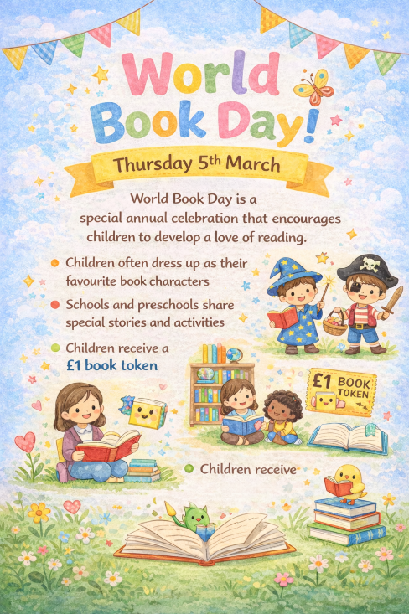
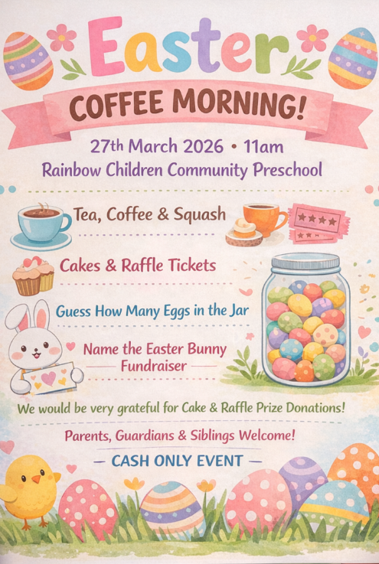
The Team at Rainbow Children Community Preschool 🌈
Rachael, Caroline, Atlanta, Sophie,
Claire, Patricia and Grace

